Assemblage

The blending together of component wine lots to form a final composite intended for bottling, for aging, for sparkling wine production or for some other use by the wine maker. Also the name given to formal membership conclaves in the wine fraternity "Knights of the Vine." (from Wine Words: WineWineWine.com)

Presented for Induction as
Knights and Gentle Ladies

Ms. Andrea Cabrera Gentle Lady-in-Waiting
Mr. David A. Caruso Knight-in-Training
Mr. Thomas Eales III Knight-in-Training
Mr. Andrew C. Schwarz Knight-in-Training

Symbolic Knight Performing Induction Rights and Representing all New Knights and Gentle Ladies

Mr. Ronald B. Natalie Senior Knight-in-Training

Aims and Purposes

The Brotherhood is an association of individuals who share an appreciation for and an interest in the vines and wines of America; proclaim their virtues and uses in a modern society by demonstrating the good life with wine through the courtesies of the table; educate themselves and the public at large that wine is a healthy and hygienic beverage and beneficial to modern life; and bring honor and distinction to those individuals who support the cause of the vines and wines of America.
the brotherhood of the
knights of the vine

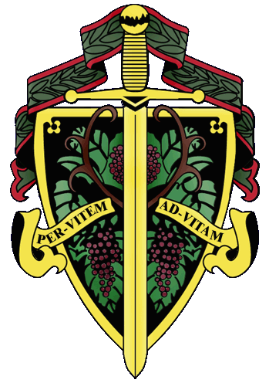

«title» «first_name» «last_name»

The Nation's Capital Chapter

Preamble

Wine is a gift from God that has been used as a food and a symbolic beverage for centuries: we have the privilege to enjoy and appreciate wine. Wine is a gift of nature. Growth of its consumption is a gift of man to man. Therefore, we bind together in the "Brotherhood" to enjoy and appreciate its use by telling of this gift in the world and by teaching Restraint and Reason.
AT THE EVENTIDE OF THE 11th DAY OF MARCH IN THE YEAR OF OUR LORD 2006

The Cadre of the Nation's Capital Chapter of the Brotherhood of the Knights of The Vine Welcomes You to Heritage Hunt Golf and Country Club in Gainesville, Virginia, for the Knighting of New Members and the Formal Dinner in Celebration of Their Acceptance into the Peerage

Officiating Officers

Master Commander Kenneth A. Haapala
Master Exchequer John (Joe) Alt
Master ďElegánce Debra Arthur
Master of Ceremony David A. Barber
Master Chargé ďAffaires Carl Brandhorst
Master Commander Emeritus Conrad Koneczny

Events

Gathering of the Peerage • 5:30 pm
Lower Lobby
Rapidan River Dry Riesling, 2003

Assemblage • 6:15 pm
Procession • Announcement of Cadre
Duties of Symbolic Knight
Tapping of Knights and Gentle Ladies
Card Room

Champagne Reception • 7:00 pm
Passed Hors d’Oeuvres
Main Lobby

Enthronement Dinner • 8:00 pm
Dinning Room

Per Vitem! Ad Vitam!
Through The Vine! Towards Life!
Champagne Reception

Fruit and Cheese Extravaganza
Mozzarella and Tomato Bruchetta
Jumbo Shrimp Splendor
Charles LaFitte, Grand Cuvée, Brut, Épernay
Louis Boullot, Crémant de Bourgogne, Brut
A.R. Lenoble, Grand Cru, Millésime, Brut, 1990

Enthronement Dinner Honoring New Members

Anser Iecur

Pan Seared Foie Gras
Caramelized Apples and Pears with Bitter Greens and Pear Crisp

Margan, , Botrytis Semillon, Hunter Valley, 2003

Marinus

Lobster Bisque with Lobster Ravioli
Barboursville Pinot Grigio, 2004
Logan Sleep Hollow Vineyards, Monterey, 2002

Interquiesco

Flowered Pineapple Sorbet

Pecus

Braised Lamb Shank
Potato Bread Pudding, Caramelized Root Vegetables
Rockbridge Heritage, 2002
Tate “Michelle’s Block” BB, Barossa Valley, 2004

Moretum

Grilled Duck Breast Salad
Spiced Pecans and Sundried Cranberry Confit
Kali Hart Vineyards, Santa Lucia Highlands, 2002

Bellaria

Hazel Nut Créme Brule with Fruits
Osborne, Pedro Ximenez

Postea

Coffee and Tea

Created and Executed by: Executive Chef Robert Fourqurean

Hosted by: Master Knight Frank Denniston

