Assemblage

The blending together of component wine lots to form a final composite intended for bottling, for aging, for sparkling wine production or for some other use by the wine maker. Also the name given to formal membership conclaves in the wine fraternity "Knights of the Vine." (from Wine Words: WineWineWine.com)

Presented for Induction as
Knights and Gentle Ladies

Mr. E. Thomas Chesworth Knight
Ms. Josephine Chesworth Gentle Lady
Ms. Beverly J. Livingston Gentle Lady
Mr. Alvin R. McNeal Knight
Mr. Steven D. Sherry Knight
Mr. Jonathan S. Wyner Knight

Symbolic Knight Performing Induction Rights and Representing all New Knights and Gentle Ladies

Mr. Peter M. Swindells Senior Knight-in-Training

Aims and Purposes

The Brotherhood is an association of individuals who share an appreciation for and an interest in the vines and wines of America; proclaim their virtues and uses in a modern society by demonstrating the good life with wine through the courtesies of the table; educate themselves and the public at large that wine is a healthy and hygienic beverage and beneficial to modern life; and bring honor and distinction to those individuals who support the cause of the vines and wines of America.
the brotherhood of the
knights of the vine

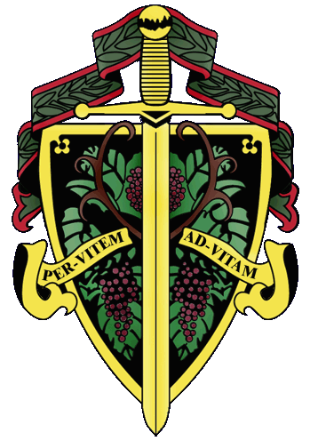

«title» «first_name» «last_name»

The Nation's Capital Chapter

Preamble

Wine is a gift from God that has been used as a food and a symbolic beverage for centuries: we have the privilege to enjoy and appreciate wine. Wine is a gift of nature. Growth of its consumption is a gift of man to man. Therefore, we bind together in the "Brotherhood" to enjoy and appreciate its use by telling of this gift in the world and by teaching Restraint and Reason.
AT THE EVENTIDE OF THE 14th DAY OF MARCH IN THE YEAR OF OUR LORD 2003

The Cadre of the Nation's Capital Chapter of the Brotherhood of the Knights Of The Vine Welcomes You to The Metropolitan Club of Washington, in our Capital City, for the Knighting of New Members and the Formal Dinner in Celebration of Their Acceptance into the Peerage

Officiating Officers

Master Commander Kenneth A. Haapala
Master Vice Commander Sandra A. Shutler
Master ďElégance Debra G. Arthur
Master Exchequer John (Joe) Alt
Master of Ceremony David A. Barber
Master Charge ďAffaires Carl Brandhorst
Master Heralder Walter J. Rachele

Events

Gathering of the Peerage • 6:30 pm
Red Room

Assemblage • 7:15 pm
Procession • Announcement of Cadre
Duties of Ceremonial Knight
Tapping of Knights and Gentle Ladies
Red Room

Champagne Reception • 8:15 pm
Passed Hors d’Oeuvres • Tour of Wine Cellar
Red Room

Enthronement Dinner • 8:45 pm
Dining and Dancing • Music • Mike Maher Trio
Anderson Room

Per Vitem! Ad Vitam!
Through The Vine! Towards Life!
Champagne Reception

Carpaccio of Young Lamb Loin served on Sliced Walnut Baguette w. Shaved Parmesan, Minced Caper, Drizzled w. White Truffle Oil
Canapé of Shrimp and Fresh White Anchovy, on Pumpernickel Round w. Red Pepper Cream and Salsify
Iranian Osetra Caviar, Buckwheat Blinies to Order, Assorted Garnishes
Assortment of Six Champagnes

Enthronement Dinner Honoring New Members

Marinus

Timbale of Lobster and Truffle
Emulsion of Sweet English Peas
Garnished with Baby Snails and Fennel Crisps
Horton Viognier, 1999
Meursaulut – Charmes, Olivier Leflaive, 1999

Intermezzo

Pecusoris

Roasted Roulade of Veal Loin stuffed with Wild Mushrooms
Spinach Spätzel and Grain Mustard and Madeira Sauce
Beaune, 1er Cru, Reversees, Domaine Carre – Courbin, 1996
Phantom Hill, Pinot Noir, Revelation Cuvee, Oregon, 1998

Moretum

Bleu ďAuvergne, Brillat Savarin and Epoisse de Bourgogne
Sliced Baguette and Baby Arugula
Chateau Calon – Segur, Grand Cru Classe, Saint-Estephe, 1996
Seavey, Cabernet Sauvignon, Napa, 1994

Bellaria

Mango Crème Franche Bavarian
Lemon Curd Ice Cream, Strawberry Vanilla Syrup

Coteaus, du Layon St. Lambert, Clos des Bonnes Blanches, 1996

Domaine Jo Pithon, Val de Loire

Postia

Chef's Delights
Expresso

Porto

Created and Executed by: Executive Chef Thomas Hayes
Hosted by: Master Knight Edward T. Brennan, Jr.
The Metropolitan Club of Washington

