Assemblage

The blending together of component wine lots to form a final composite intended for bottling, for aging, for sparkling wine production or for some other use by the wine maker. Also the name given to formal membership conclaves in the wine fraternity "Knights of the Vine." (from Wine Words: WineWineWine.com)

Peers Elevated in Rank

Master Scribe Charles (Russ) Davis Master Vice Commander
Gentle Lady Mary Anne Wassenberg Master Scribe

Presented for Induction as
Knights and Gentle Ladies

Ms. Jennifer L. Crafts Gentle Lady-in-Waiting
Mr. Alexander C. Ehrlich Knight-in-Training
Mr. Charles C. Franklin Knight-in-Training
Ms. Margery A. Natalie Gentle Lady-in-Waiting
Mr. Ted Yezek Knight-in-Training

Symbolic Knight Performing Induction Rights Representing all New Knights and Gentle Ladies

Mr. Rex R. Bambling Senior Knight-in-Training

Aims and Purposes

The Brotherhood is an association of individuals who share an appreciation for and an interest in the vines and wines of America; proclaim their virtues and uses in a modern society by demonstrating the good life with wine through the courtesies of the table; educate themselves and the public at large that wine is a healthy and hygienic beverage and beneficial to modern life; and bring honor and distinction to those individuals who support the cause of the vines and wines of America.
the brotherhood of the
knights of the vine

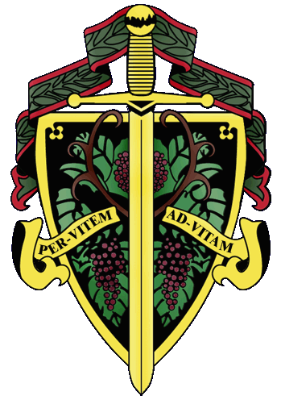

Master Commander Kenneth A. Haapala

The Nation's Capital Chapter

Preamble

Wine is a gift from God that has been used as a food and a symbolic beverage for centuries: we have the privilege to enjoy and appreciate wine. Wine is a gift of nature. Growth of its consumption is a gift of man to man. Therefore, we bind together in the "Brotherhood" to enjoy and appreciate its use by telling of this gift in the world and by teaching Restraint and Reason.
AT THE EVENTIDE OF THE 24th DAY OF MARCH IN THE YEAR OF
OUR LORD 2007

The Cadre of the Nation's Capital Chapter of the Brotherhood of the Knights of The Vine Welcomes You to The Hotel George and Bistro Bis, on Capitol Hill for the Knighting of New Members and the Formal Dinner in Celebration of Their Acceptance into the Peerage

Officiating Officers

Master Commander Kenneth A. Haapala
Master Vice Commander Charles (Russ) Davis
Master Exchequer John (Joe) Alt
Master of Ceremony David A. Barber
Master Chargé ďAffaires Carl G. Brandhorst
Master Heralder Walter J. Rachele
Master Scribe Mary Anne Wassenberg

Events

Gathering of the Peerage • 6:15 pm
Lower Lobby • The Hotel George

Assemblage • 6:45 pm
Procession • Announcement of Cadre
Duties of Symbolic Knight
Tapping of Knights and Gentle Ladies
Assembly Room

Champagne Reception • 7:30 pm
Passed Hors d’Oeuvres
Assembly Room

Enthronement Dinner • 8:00 pm
Dinning Room

Per Vitem! Ad Vitam!
Through the Vine! Towards Life!
Champagne Reception

Artichoke beignet with lobster aioli
Tartine provençale with marinated white anchovy
Begger’s purse with lamb confit, olives and chevré
Hunold Crémant d’Alsace, Brut
Heidsiek Monopole “Blue Top” Brut
A.R. Lenoble, Grand Cru, Millésime, Brut, 1990

Enthronement Dinner Honoring New Members

Peloridis
Crique et Langoustes
Ardeche style potato cake with langoustines, honey cap
mushrooms, arugula and langoustine cream

Cottonwood Canyon Estate Chardonnay, Santa Maria, 1997

Marinus
Turbotin Aux Printemps
Young turbot fillet with Path Valley Farms spring vegetables
and fines herbes nage
Horton Viognier, Orange County, 2006
Toluca Lane Pinot Noir, Oregon, 2002

Interquiesco
Sorbet De Pamplemousse

Pecus
Noissette ďAgneau Elizabeth
Lamb loin wrapped in mushroom and artichoke crépinette
with celery root purée and rosemary jus
d’Arenberg Laughing Magpie Shiraz, McLaren Vale, 2001
Penley Estate Reserve Cabernet Sauvignon, Coonawarra, 1999

Moretum
Torta Del Casar
Earthy sheep’s milk cheese from Spain with kumquat
marmalade, toasted brioche, and filberts
Lealtanza Rioja, Crianza, 2001

Bellaria
Chocolate Marquise
Valhrona chocolate mousse with pistachio ice cream
and red wine infused cherries
Mayo Family Zinfandel Port, Russian River, 2002

Chef Jeffrey & Sallie Buben, Proprietors

Joseph Harran, Chef de Cuisine

Andrew Policelli, Pastry Chef

