Assemblage

The blending together of component wine lots to form a final composite intended for bottling, for aging, for sparkling wine production or for some other use by the wine maker. Also the name given to formal membership conclaves in the wine fraternity "Knights of the Vine." (from Wine Words: WineWineWine.com)

Peers Elevated in Rank

Master Knight Christopher Breiner Master Winemaker

Presented for Induction as
Knight

Mr. David Lynch Knight-in-Training

Symbolic Knight Performing Induction Rights Representing Knights and Gentle Ladies

Mr. David Lynch Knight-in-Training

Aims and Purposes

The Brotherhood is an association of individuals who share an appreciation for and an interest in the vines and wines of America; proclaim their virtues and uses in a modern society by demonstrating the good life with wine through the courtesies of the table; educate themselves and the public at large that wine is a healthy and hygienic beverage and beneficial to modern life; and bring honor and distinction to those individuals who support the cause of the vines and wines of America.
the brotherhood of the
knights of the vine

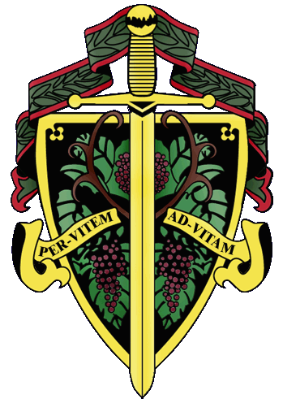
Master Commander Kenneth A. Haapala

The Nation's Capital Chapter

Preamble

Wine is a gift from God that has been used as a food and a symbolic beverage for centuries: we have the privilege to enjoy and appreciate wine. Wine is a gift of nature. Growth of its consumption is a gift of man to man. Therefore, we bind together in the "Brotherhood" to enjoy and appreciate its use by telling of this gift in the world and by teaching Restraint and Reason.
AT THE EVENTIDE OF THE 26th DAY OF MARCH IN THE YEAR OF
OUR LORD 2010

The Cadre of the Nation's Capital Chapter of the Brotherhood of the Knights of The Vine Welcomes You to The Historic Belle Haven Country Club for the Knighting of New Members and the Formal Dinner in Celebration of Their Acceptance into the Peerage

Officiating Officers

Master Commander Kenneth A. Haapala
Master Vice Commander Charles (Russ) Davis
Master Exchequer John (Joe) Alt
Master of Ceremony David A. Barber
Master Hôte Patrick Finn
Master Heralder Walter J. Rachele
Master Scribe Mary Anne Wassenberg

Events

Gathering of the Peerage • 6:45 pm

Assemblage • 7:15 pm
Procession • Announcement of Cadre
Elevation of Officers
Duties of Symbolic Knight
Tapping of Knight
Assembly Room

Champagne Reception • 7:50 pm
Passed Hors d’Oeuvres
Assembly Room

Enthronement Dinner • 8:30 pm
Dinning Room

Per Vitem! Ad Vitam!
Through the Vine! Towards Life!
Champagne Reception
Foie Gras de Canard on Brioche
Demi-Tasse of Cappuccio of Forest Mushroom, Truffle Oil
Tuan Tartar, Potato Gaufrette
Veal Cheeks Lollipops
Cremont de Bourgogne, Blanc de Blanc, Domain du Chateau de Chorey
A.R. Lenoble, Grand Cru, Millésime, Brut, 1990

Enthronement Dinner Honoring New Members

Marinus
Homard et Coueilles Saint-Jacques à ľAméricaine, en Croûte
Saint-Aubin, 1er Cru, En Remilly, 2005, Domaine Larue

Altilis
Confit de Canard et Escalope de Canard Fumé
Chokecherry Cumberland Souse
Nest of Golden Frisée and Emulsion of champagne and Cider Vinegar
Morgan, Double L Vineyard, Piont Noir, 2007, Santa Lucia Highlands

Interquiesco
B;aclberroes amd Cabermet Sauvignon Sorbet

Pecus
Rôte Filet ďAgneau aux Thyme
Roasted Shallot and Cabernet Sauvignon Lamb Demi
Gratin Potato with Emmental cheese
Wilted Baby Spinach and Kaleidoscope Beet Roots
Franciscan Magnificant, 2006, Napa Valley
Crozes Hermitage, Syrah, Les Fess Brues, 2006, Jean-Luc Colombo

Moretum
Tomme de Savoie et bleu D’Auvergnoe and Monocacy Chèvre
Port Poached Bosc Pear
Porto Wine Marmalade, Quince Gelèe, Artisan Raisin-Walnut Bread
La Bastide Saint Dominique, Cuvée Jules Rochebonne, 2007,

Bellaria
Chocolate Opera Cake
Madagascar Vanilla Pot de Crème
Mango Sorbet and Coulis of Red Field Berries
Croft 10 Year Old Tawny Port

Completus
Chef Max’s Chocolate Bonbons
Almond Mignardises

Master Knight “Chip” Brennan, General Manager

Philippe Knoepfel, Chef de Cuisine

Nicole Duncan, Banquet Director

