Assemblage

The blending together of component wine lots to form a final composite intended for bottling, for aging, for sparkling wine production or for some other use by the wine maker. Also the name given to formal membership conclaves in the wine fraternity "Knights of the Vine." (from Wine Words: WineWineWine.com)

Symbolic Knight Performing Induction Rights Representing all New Knights and Gentle Ladies

Sir Knight Senior Knight-in-Training

Guests of Honor

Richard Hagner Grand Commander
Trish Hagner Master Gentle Lady

Aims and Purposes

The Brotherhood is an association of individuals who share an appreciation for and an interest in the vines and wines of America; proclaim their virtues and uses in a modern society by demonstrating the good life with wine through the courtesies of the table; educate themselves and the public at large that wine is a healthy and hygienic beverage and beneficial to modern life; and bring honor and distinction to those individuals who support the cause of the vines and wines of America.
the brotherhood of the
knights of the vine

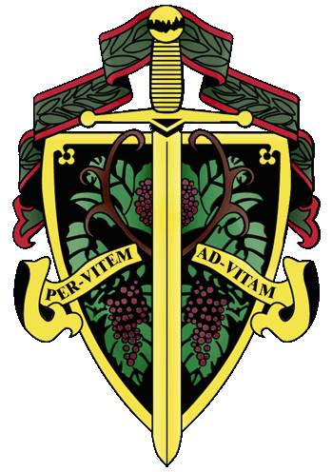

The Nation's Capital Chapter

Preamble

Wine is a gift from God that has been used as a food and a symbolic beverage for centuries: we have the privilege to enjoy and appreciate wine. Wine is a gift of nature. Growth of its consumption is a gift of man to man. Therefore, we bind together in the "Brotherhood" to enjoy and appreciate its use by telling of this gift in the world and by teaching Restraint and Reason.
AT THE EVENTIDE OF THE 9th DAY OF APRIL IN THE YEAR OF
OUR LORD 2016

The Cadre of the Nation's Capital Chapter of the Brotherhood of the Knights of the Vine Welcomes You to The Inn at Willow Grove in Orange, Virginia for the Elevation of Members, the Knighting of New Members and the Formal Dinner in Celebration of Their Acceptance into the Peerage

Officiating Officers

Master Commander Kenneth A. Haapala
Master Vice Commander Charles (Russ) Davis
Master of Ceremonies David A. Barber
Master Aviatrix Margy Natalie
Master Heralder Walter J. Rachele
Master Boulevardier Anthony Ramdass
Master Scribe MaryAnn Wassenberg

Events

Gathering of the Peerage • 6:00 pm

Assemblage • 6:30 pm
Duties of Symbolic Knight
Celebration of Membership

Reception • 7:00 pm

Enthronement Dinner • 7:30 pm

Per Vitem! Ad Vitam!
Through the Vine! Towards Life!
Champagne Reception

Charles de Marques, Brut
A.R. Lenoble, Grand Cru, Millésime, Blanc de Blancs, 1990
Chateau de Lancyre, Pic Saint-Loup, 2010

Enthronement Dinner Honoring Membership

Fumosa Acupenser

Smoked Salmon Cheese Cake with Chives and Myer Lemon Custard
House-made Bread and Honey Butter
Barboursville Pinot Grigio

Peloridis

Seared Scallops au Gratin with Enoki Mushrooms, Smoked Seaweed and Scallop Mayo
Gray Ghost Victorian White

Peloridis

Sweet Tea Grilled Quail, Collard Green Eggroll, Peanut Sauce
Gray Ghost Ranger Reserve
Brown Bag Chardonnay, Russian River

Interquiesco

Grapefruit & Tarragon Granite

Coturnix
Double Cooked Beef Tenderloin, Tomato Jus, Baby Spinach
Parsnip Puree
Bernadotte, Haut-Médoc, 2003
Worthy, Sophia’s Curvée, Napa, 2010

Bellaria

Bitter Chocolate Mousse with sea salt, bacon straws,
Fresh fruit and Sweet cream
Misty Mountain Mead
Andresen Fine Tawny

Created and Executed by Chef Jason Daniels

