Assemblage

The blending together of component wine lots to form a final composite intended for bottling, for aging, for sparkling wine production or for some other use by the wine maker. Also the name given to formal membership conclaves in the wine fraternity "Knights of the Vine." (from Wine Words: WineWineWine.com)

Presented for Induction as
Knights and Gentle Ladies

Ms. Sheryl P. Shrenchengost Gentle Lady-in-Waiting
Ms. Karla L. Snellings Gentle Lady-in-Waiting

Symbolic Peer Performing Induction Rights Representing all New Gentle Ladies

Ms. Karla L. Snellings Gentle Lady-in-Waiting

Aims and Purposes

The Brotherhood is an association of individuals who share an appreciation for and an interest in the vines and wines of America; proclaim their virtues and uses in a modern society by demonstrating the good life with wine through the courtesies of the table; educate themselves and the public at large that wine is a healthy and hygienic beverage and beneficial to modern life; and bring honor and distinction to those individuals who support the cause of the vines and wines of America, and for the Nation’s Capital Chapter, especially Virginia
the brotherhood of the
knights of the vine

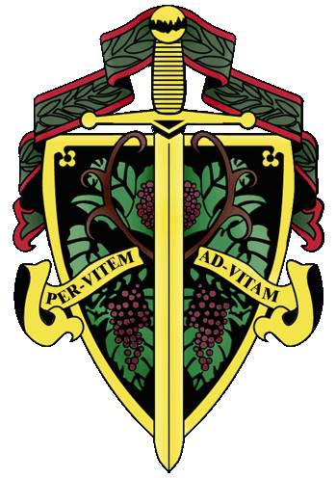

Master Exchequer Joe Alt

The Nation's Capital Chapter

Preamble

Wine is a gift from God that has been used as a food and a symbolic beverage for centuries: we have the privilege to enjoy and appreciate wine. Wine is a gift of nature. Growth of its consumption is a gift of man to man. Therefore, we bind together in the "Brotherhood" to enjoy and appreciate its use by telling of this gift in the world and by teaching Restraint and Reason.
AT THE EVENTIDE OF THE 14th DAY OF APRIL IN THE YEAR OF
OUR LORD 2012

The Cadre of the Nation's Capital Chapter of the Brotherhood of the Knights of The Vine Welcomes You to The City Club of Washington, Washington, DC, for the Knighting of New Members and the Formal Dinner in Celebration of Their Acceptance into the Peerage

Officiating Officers

Master Commander Kenneth A. Haapala
Master Vice Commander Charles (Russ) Davis
Master Exchequer John (Joe) Alt
Master of Ceremony David A. Barber
Master Chargé ďAffaires Carl G. Brandhorst
Master Heralder Walter J. Rachele

Events

Gathering of the Peerage • 6:00 pm
Lobby – City Club of Washington

Assemblage • 6:30 pm
Procession • Announcement of Cadre
Duties of Symbolic Peer
Tapping of Gentle Ladies
Fountain Lobby

Champagne Reception • 7:15 pm
Passed Hors d’Oeuvres
Media Lounge

Enthronement Dinner • 8:00 pm
Jefferson Room

Per Vitem! Ad Vitam!
Through the Vine! Towards Life!
Champagne Reception
Mini Cheddar Bisquites with Virginia Ham and Sweet Mustard
Crab and Tomato Brushchetta
Imported and Domestic Cheeses
Gilet, Vouvray, Brut,
A.R. Lenoble, Grand Cru, Millésime, Brut, 1990

Enthronement Dinner Honoring New Members

Marinus

Ceviché De Pescado
Horton Viognier, Orange County, 2007
Domaine Doblìre,, Les Millerands, Blair –Pethel, 2009

Moretum

Caprese – Balsamic & Mozzarella
Chateau de Lancyre, Pic Saint-Loup, Coteaux du Languedoc, 2010

Interquiesco
Sorbet

Pecus

Noissette ďAgneau
Lamb Loin with Red Wine & Mushroom Demi
Blue Cheese Scalloped Potatoes, Grilled Asparagus
Pic & Chapoutier, Crozes-Hermitage, 2009
Château Bourgneuf, Pomerol, 1985

Bellaria

Chocolate Marquise
Triple Chocolate Mousse Cake w.
Expresso Créme Anglaisé
R.L. Buller & Son, Premium Fine Tawny, Victoria

Chef: Steven Fender

Host: Ian MacDonald

