Assemblage

The blending together of component wine lots to form a final composite intended for bottling, for aging, for sparkling wine production or for some other use by the wine maker. Also the name given to formal membership conclaves in the wine fraternity "Knights of the Vine." (from Wine Words: WineWineWine.com)

Elevated to the Cadre

Knight Charles Russell Davis Master Scribe

Presented for Induction as
Knights and Gentle Ladies

Ms. Nancy L. Davis Gentle Lady
Ms. K. Casey Finn Gentle Lady
Mr. Delbert (Del) D. Konnor Knight
Mr. Thomas E. Rodebaugh Knight
Ms. Dawn J.D.J. Swindells Gentle Lady

Symbolic Knight Performing Induction Rights and Representing all New Knights and Gentle Ladies

Mr. Vernon M. Danielsen Master Knight

Aims and Purposes

The Brotherhood is an association of individuals who share an appreciation for and an interest in the vines and wines of America; proclaim their virtues and uses in a modern society by demonstrating the good life with wine through the courtesies of the table; educate themselves and the public at large that wine is a healthy and hygienic beverage and beneficial to modern life; and bring honor and distinction to those individuals who support the cause of the vines and wines of America.
the brotherhood of the
knights of the vine

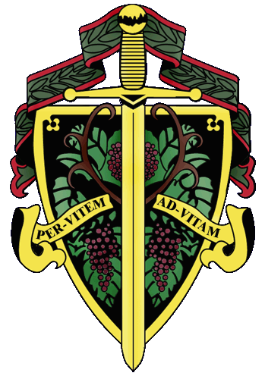

Gentle Lady Christine Braun

The Nation's Capital Chapter

Preamble

Wine is a gift from God that has been used as a food and a symbolic beverage for centuries: we have the privilege to enjoy and appreciate wine. Wine is a gift of nature. Growth of its consumption is a gift of man to man. Therefore, we bind together in the "Brotherhood" to enjoy and appreciate its use by telling of this gift in the world and by teaching Restraint and Reason.
AT THE EVENTIDE OF THE 1st DAY OF May IN THE YEAR OF OUR LORD 2004

The Cadre of the Nation's Capital Chapter of the Brotherhood of the Knights Of The Vine Welcomes You to The Grant Memorial Reflecting Pool, at Capitol Hill, for the Knighting of New Members and the Formal Dinner at The Caucus Room in Celebration of Their Acceptance into the Peerage

Officiating Officers

Master Commander Kenneth A. Haapala
Master Vice Commander Sandra A. Shutler
Master ďElégance Debra G. Arthur
Master Exchequer John (Joe) Alt
Master of Ceremony David A. Barber
Master Chargé ďAffaires Carl G. Brandhorst
Master Scribe Charles (Russ) Davis
Master Heralder Walter J. Rachele

Events

Gathering of the Peerage • 6:00 pm
Grant Memorial Reflecting Pool, Capitol Hill

Assemblage • 6:15 pm
Procession • Announcement of Cadre
Duties of Ceremonial Knight
Tapping of Knights and Gentle Ladies
Grant Memorial Reflecting Pool, Capitol Hill

Champagne Reception • 7:45 pm
Passed Hors d’Oeuvres • The Caucus Room

Enthronement Dinner • 8:30 pm
The Caucus Room

Per Vitem! Ad Vitam!
Through The Vine! Towards Life!
Champagne Reception

Crab Cigars
Caviar - Caviar
Roasted Bell Pepper Tarts with Goat Cheese
Duck with Orange and Tarragon
Charles LaFitte, Grand Cuvée, Brut, Épernay
Montaudon Millésime, Brut, Reims, 1996
A. R. Lenoble, Grand Cru, Millésime, Brut, 1990

Enthronement Dinner Honoring New Members

Moretum

Scallop Salad with Green Apple and Hazelnuts
Chrysalis Viognier, 1999

Anser Iecur

Foie Gras with Celeriac and Fig Essence
Margan, Botrytis Semillon, Hunter Valley, 2002

Intermezzo
Yellow Grapefruit Sorbet with Campari and Basil

Marinus

Tuna Andalusia with Mediterranean Vegetables
Saint Véran, “La Vieille Vigne Des Crêches”, 2002
Savigny-les-Beaune, 1st Cru, Côte d’Or, 1999

Bublus

Herb Crusted Prime Rib with Red Wine Sauce and Truffle Potato Puree
St. Supery Cabernet Sauvignon, Dollarhide Ranches, Napa, 1995
Barboursville Octagon V, 2001

Bellaria

Warm Chocolate Tart with Compote of Michigan Cherries

Gray Ghost “Adieu” Late Harvest Vidal, 2002

Postia

Chef's Delights

Porto Moreira, 1997
Expresso

Created and Executed by: Executive Chef Richard Beckel
Hosted by: Michael Sternberg, Proprietor
The Caucus Room, Washington, DC

