Assemblage

The blending together of component wine lots to form a final composite intended for bottling, for aging, for sparkling wine production or for some other use by the wine maker. Also the name given to formal membership conclaves in the wine fraternity "Knights of the Vine." (from Wine Words: WineWineWine.com)

Presented for Induction as
Knights and Gentle Ladies

Mr. Robert Beard Knight-in-Training
Ms. Helen Evans Gentle Lady-in-Waiting
Mr. Peter Evans Knight-in-Training

Symbolic Knight Performing Induction Rights and Representing all New Knights and Gentle Ladies

Mr. Christopher Breiner Senior Knight-in-Training

Aims and Purposes

The Brotherhood is an association of individuals who share an appreciation for and an interest in the vines and wines of America; proclaim their virtues and uses in a modern society by demonstrating the good life with wine through the courtesies of the table; educate themselves and the public at large that wine is a healthy and hygienic beverage and beneficial to modern life; and bring honor and distinction to those individuals who support the cause of the vines and wines of America.
the brotherhood of the
knights of the vine

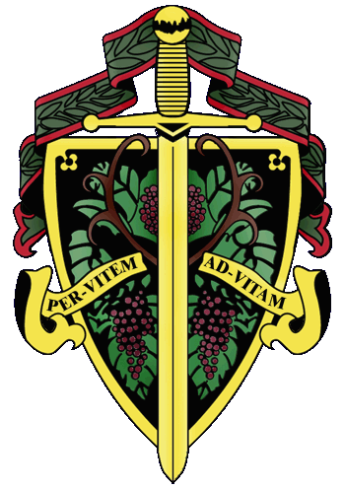

«title» «first_name» «last_name»

The Nation's Capital Chapter

Preamble

Wine is a gift from God that has been used as a food and a symbolic beverage for centuries: we have the privilege to enjoy and appreciate wine. Wine is a gift of nature. Growth of its consumption is a gift of man to man. Therefore, we bind together in the "Brotherhood" to enjoy and appreciate its use by telling of this gift in the world and by teaching Restraint and Reason.
AT THE EVENTIDE OF THE 6th DAY OF MAY IN THE YEAR OF OUR LORD 2005

The Cadre of the Nation's Capital Chapter of the Brotherhood of the Knights of The Vine Welcomes You to United States Botanic Gardens, in our Capital City, for the Knighting of New Members and the Formal Dinner in Celebration of Their Acceptance into the Peerage

Officiating Officers

Master Commander Kenneth A. Haapala
Master Exchequer John (Joe) Alt
Master of Ceremony David A. Barber
Master Charge ďAffaires Carl Brandhorst
Master Gastronome Sergio Micheli
Master Heralder Walter J. Rachele
Master Commander Emeritus Conrad Koneczny

Events

Gathering of the Peerage • 6:30 pm
West Wing • Garden Court
Rapidan River Dry Riesling, Virginia, 2003

Assemblage • 6:45 pm
Procession • Announcement of Cadre
Duties of Ceremonial Knight
Tapping of Knights and Gentle Ladies
West Wing • Garden Court

Champagne Reception • 7:30 pm
Passed Hors d’Oeuvres
West Wing • Garden Court

Enthronement Dinner • 8:15 pm
Center • Garden Court

Per Vitem! Ad Vitam!
Through The Vine! Towards Life!
Champagne Reception

Artichoke and Ricotta Fritters with Meyer Lemon Sauce
Zucchini, Brie and Prosciutto Purses
Potato, Apple Pancakes with Smoked Salmon
Grilled Duck on Pear Chips
Charles LaFitte, Grand Cuvée, Brut, Épernay
Louis Drescher, Nobles Cépages, Brut
A.R. Lenoble, Grand Cru, Millésime, Brut, 1990

Enthronement Dinner Honoring New Members

Prologus

Sweet Corn Soup with Shiitake Crab Cake
Hartwood Station White, Virginia

Marinus

Lemon Herb Crusted Rockfish
Roasted Asparagus Spears and Baby Carrots with Tops
Mercurey, Burgundy, 1998
Kali Hart Vineyards, Santa Lucia Highlands, 2002

Interquiesco

Tart Lemon and Fresh Sweet Basil Sorbet

Bublus

Filet Mignon with Blackberry Port Wine Sauce
Rustic Yukon Gold and Vidalia Onion Tart
St. Supéry, Dollarhide Ranches, Napa, 1995
St. Andrews Estate, Adelaide Plains, 2000

Moretum

Boston and Radicchio Leaves with Asiago Cheese and Peppered Almonds

Bellaria

Pistachio Popover Crème Brulee

Margan, Hunter Valley, Botrytis Semillon, 2003

Postea

Assiette of Chocolate

Coffee and Tea

Created and Executed by: Well Dunn Catering, Washington, DC
Chef: José Parada
The U.S. Botanic Gardens, Washington, DC

