Assemblage

The blending together of component wine lots to form a final composite intended for bottling, for aging, for sparkling wine production or for some other use by the wine maker. Also the name given to formal membership conclaves in the wine fraternity "Knights of the Vine." (from Wine Words: WineWineWine.com)

Peers Elevated in Rank

Gentle Lady Margy Natalie Master Aviatrix
Knight Eric Novotny Master Zetetic
Knight Anthony Ramdass Master Boulevardier

Presented for Induction as
Knights and Gentle Ladies

Ms. Claire Cuccio Gentle Lady-in-Waiting
Ms. Beth M. McCormick Gentle Lady-in-Waiting
Mr. Richard M. McCormick Knight-in-Training
Major General John O.B. Sewall Knight-in-Training

Symbolic Knight Performing Induction Rights Representing all New Knights and Gentle Ladies

Mr. Richard R. Abelkis Senior Knight-in-Training

Aims and Purposes

The Brotherhood is an association of individuals who share an appreciation for and an interest in the vines and wines of America; proclaim their virtues and uses in a modern society by demonstrating the good life with wine through the courtesies of the table; educate themselves and the public at large that wine is a healthy and hygienic beverage and beneficial to modern life; and bring honor and distinction to those individuals who support the cause of the vines and wines of America.
the brotherhood of the
knights of the vine

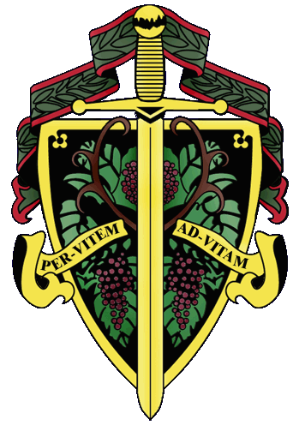

Master Commander Kenneth A. Haapala

The Nation's Capital Chapter

Preamble

Wine is a gift from God that has been used as a food and a symbolic beverage for centuries: we have the privilege to enjoy and appreciate wine. Wine is a gift of nature. Growth of its consumption is a gift of man to man. Therefore, we bind together in the "Brotherhood" to enjoy and appreciate its use by telling of this gift in the world and by teaching Restraint and Reason.
AT THE EVENTIDE OF THE 11th DAY OF MARCH IN THE YEAR OF
OUR LORD 2013

The Cadre of the Nation's Capital Chapter of the Brotherhood of the Knights of the Vine Welcomes You to The Hotel George and Bistro Bis, on Capitol Hill for the Elevation of Members, the Knighting of New Members and the Formal Dinner in Celebration of Their Acceptance into the Peerage

Officiating Officers

Master Commander Kenneth A. Haapala
Master Vice Commander Charles (Russ) Davis
Master Exchequer John (Joe) Alt
Master of Ceremony David A. Barber
Master Chargé ďAffaires Carl G. Brandhorst
Master Heralder Walter J. Rachele
Master Scribe Mary Anne Wassenberg

Events

Gathering of the Peerage • 6:15 pm
Lower Lobby • The Hotel George

Assemblage • 6:45 pm
Procession • Announcement of Cadre
Duties of Symbolic Knight
Tapping of Knights and Gentle Ladies
Assembly Room

Champagne Reception • 7:30 pm
Passed Hors d’Oeuvres
Assembly Room

Enthronement Dinner • 8:00 pm
Dinning Room

Per Vitem! Ad Vitam!
Through the Vine! Towards Life!
Champagne Reception

Duck Confit and Morello Cherry Turnover
Citrus Cured Salmon Tartare
Oyster Gratin Florentine
Polo Club, Brute
Jacquart Champagne, Rosé, Brut
La Torera Brunei, Prosecco
A.R. Lenoble, Grand Cru, Millésime, Blanc de Blancs, 1990
Croney Three Ton Sauvignon Blanc, 2011

Enthronement Dinner Honoring New Members

Peloridis
Smoked Sea Scallop Printaniere
Grilled Asparagus, Blistered Grapes, Upland Cress
Pinked peppercorn cream fraïche and verjus gelé

Bai Gorri Blanco, Cosecha

Marinus
Halibut a la Nantua
Spring peas, leeks, crayfish-tarragon relish
Sunchoke mousseline and crayfish emusion,
Beauroy, Chablis Premier Cru, 2008
Pali Rivera Pinot Noir, Sonoma, 2010

Interquiesco
Buttermilk Sorbet

Pecus
Duet d’Agneau Provençale
Lamb loin medallion and “osso bucco” with roasted fennel,
Potato-chèvre gratin, niçoise olives and citrus lamb jus
Jaspi Maragda Montsant, 2008
Cooper Vineyard Petit Verdot, Reserve, Virginia, 2010
Penley Estate Cabernet Sauvignon Reserve, Connawarra, 1998

Moretum
Gorgonzola Picante Guffanti
Mountain gorgonzola with walnut butter and pickled pear purée

Bellaria
Dark Chocolate Pavé
With cherry-rhubarb compote, olive oil ice cream, and fleur de sel
d’ Arenberg, McLaren Vale, Vintage Shiraz Port, 2003

Chef Jeffrey & Sallie Buben, Proprietors

Edward Walker, Chef de Cuisine

Amanda Johnson, Pastry Chef

