Assemblage

The blending together of component wine lots to form a final composite intended for bottling, for aging, for sparkling wine production or for some other use by the wine maker. Also the name given to formal membership conclaves in the wine fraternity "Knights of the Vine." (from Wine Words: WineWineWine.com)

Presented for Induction as
Knights and Gentle Ladies

Ms. Christine L. Braun Gentle Lady
Mr. Frank J. Denniston Master Knight
Mr. Albert J. Glover Knight
Mr. Daniel A. Neja Knight
Mr. Philip C. Strother Knight
Ms. Mary Anne Wassenberg Gentle Lady
Mr. Michael W. Wassenberg Knight

Symbolic Knight Performing Induction Rights and Representing all New Knights and Gentle Ladies

Mr. William C. Landis Senior Knight-in-Training

Aims and Purposes

The Brotherhood is an association of individuals who share an appreciation for and an interest in the vines and wines of America; proclaim their virtues and uses in a modern society by demonstrating the good life with wine through the courtesies of the table; educate themselves and the public at large that wine is a healthy and hygienic beverage and beneficial to modern life; and bring honor and distinction to those individuals who support the cause of the vines and wines of America.
the brotherhood of the
knights of the vine

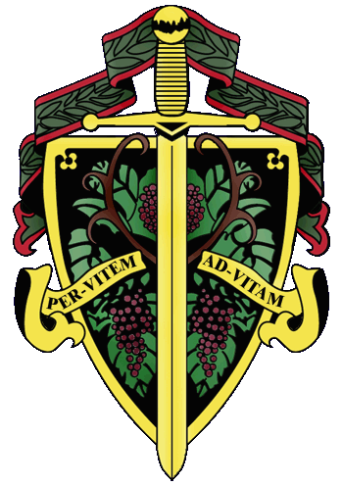

«title» «first_name» «last_name»

The Nation's Capital Chapter

Preamble

Wine is a gift from God that has been used as a food and a symbolic beverage for centuries: we have the privilege to enjoy and appreciate wine. Wine is a gift of nature. Growth of its consumption is a gift of man to man. Therefore, we bind together in the "Brotherhood" to enjoy and appreciate its use by telling of this gift in the world and by teaching Restraint and Reason.
AT THE EVENTIDE OF THE 20th DAY OF MAY IN THE YEAR OF OUR LORD 2000

The Cadre of the Nation's Capital Chapter of the Brotherhood of the Knights Of The Vine Welcomes You to Lansdowne Resort in the City of Leesburg, Virginia for the Knighting of New Members and the Formal Dinner in Celebration of their Knighthood

Officiating Officers

Master Commander Kenneth A. Haapala
Master Vice Commander Sandra A. Shutler
Master Exchequer John (Joe) Alt
Master of Ceremony David A. Barber
Master Scribe Patricia Callahan
Master Heralder Walter J. Rachele

Events
Gathering of the Peerage • 5:30 pm
Conant Room

Assemblage • 6:00 pm
Procession • Announcement of Cadre
Duties of Ceremonial Knight
Tapping of Knights and Gentle Ladies
Conant Room

Champagne Reception • 7:00 pm
Passed Hors d’Oeuvres
East Kiosk

Formal Dinner • 7:45 pm
Dining and Dancing • Music • Glenn Dewey Trio
Thurber Room

Per Vitem! Ad Vitam!
Through The Vine! Towards Life!
Gathering of the Peerage
Monterey Peninsula Sauvignon Blanc, 1997

Champagne Reception

Salmon Canapé with Cucumber Dill Créme Friache
Ahi Tuna on Roasted Fingerling Potato, Wasabi Sauce
Miniature Lamb Chops
Oasis 2000 Brut Cuvée d’Or

Enthronement Dinner Honoring New Members

Wild Mushroom Soup
Linden Sauvignon Blanc, Glen Manor, 1998
Barboursville Pinot Grigio, 1999

Marinated Lobster with Assorted Greens
Garlic Vinaigrette
Williamsburg Chardonnay, Reserve, 1997

Veal Tenderloin with Jumbo Lump Crabmeat
Wilted Greens and Reduced Au Jus
Chorey Les Beaune, 1996
Tarara Meritage, 1997

Seared Filet Mignon with Foie Gras Butter
Truffle Mashed Potatoes, Chef's Select Vegetables
Barboursville Sangiovese, 1998
Deakin Estates Shiraz, 1999

White Chocolate Mousse Cake with Rasberry Sauce
Lansdowne Coffee, Assorted Teas
Grand Imperial

Created and Executed by: Executive Chef Peter Pryor
Hosted by: Lynn Iannizze
Lansdowne Resort, Leesburg, Virginia

