Assemblage

The blending together of component wine lots to form a final composite intended for bottling, for aging, for sparkling wine production or for some other use by the wine maker. Also the name given to formal membership conclaves in the wine fraternity "Knights of the Vine." from Wine Words: WineWineWine.com

Presented for Induction as
Knights and Gentle Ladies

Mr. Hugh A. Adams Knight
Ms. Debra G. Arthur Gentle Lady
Mr. Kenneth W. Arthur Knight
Mr. Mervin R. Greenwood Knight
Ms. Joan E. O'Dell Gentle Lady
Ms. Roma D. Sherman Gentle Lady

Symbolic Gentle Lady Performing Induction Rights and Representing all New Knights and Gentle Ladies

Ms. Caroline L.T. Smith Gentle Lady

Aims and Purposes

The Brotherhood is an association of individuals who share an appreciation for and an interest in the vines and wines of America; proclaim their virtues and uses in a modern society by demonstrating the good life with wine through the courtesies of the table; educate themselves and the public at large that wine is a health and hygienic beverage and beneficial to modern life; and bring honor and distinction to those individuals who support the cause of the vines and wines of America.
the brotherhood of the
knights of the vine

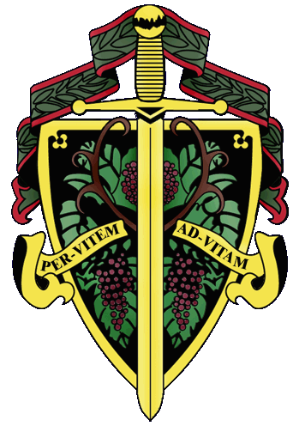

The Nation's Capital Chapter

Preamble

Wine is a gift from God which has been used as a food and a symbolic beverage for centuries: we have the privilege to enjoy and appreciate wine. Wine is a gift of nature. Growth of its consumption is a gift of man to man. Therefore, we bind together in the "Brotherhood" to enjoy and appreciate its use by telling of this gift in the world and by teaching Restraint and Reason.
AT THE EVENTIDE OF THE 19th DAY OF JUNE IN THE YEAR OF OUR LORD 1999

The Cadre of the Nation's Capital Chapter of the Brotherhood of the Knights Of The Vine Welcomes You to The University Club of the City of Washington for the Knighting of New Members and the Formal Dinner in Celebration of their Knighthood

Officiating Officers
Master Commander Kenneth A. Haapala
Master Vice Commander Sandra A. Shutler
Master of Ceremonies David A. Barber
Master Charge d' Affairs Carl G. Brandhorst
Master Scribe Patricia Callahan
In Attendance
Grand Treasurer Donald D. Bade
Grand Council Secretary Carol Bade
Provost General, West Roland V. Medel
Padre of the Vines Rev. Robert A. Skeris

Events
Gathering of the Peerage • 5:30 pm
Gallery

Assemblage • 6:00 pm
Procession • Announcement of Cadre
Duties of Ceremonial Gentle Lady
Tapping of Knights and Gentle Ladies
University Hall

Champagne Reception • 7:00 pm
Harpist Susan Abkin • Gallery

Formal Dinner • 7:45 pm
Dining and Dancing Music • Glenn Dewey Trio
The Ball Room

Per Vitem! Ad Vitam!
Through The Vine, Towards Life
Gathering of the Peerage

Champagne Reception
Smoked Salmon Pinwheels
Maine Lobster Waldorf Salad Tarts
Paté Maize Toasts
Oasis 2000 Brut Cuvée d’Or

Nicolas Feuillatte Brut Premier Cru

Enthronement Dinner of New Members

Marinated Jumbo Lump Crab with Nectarine Lime Salad
Snipped Chives and Crisp Lotus Chips
St. Supéry White Meritage, 1997

Fresh Asparagus and Morel Mushroom Risotto with
Yellow Pepper Coulis
St. Supéry Chardonnay, 1997
White Hall Reserve Chardonnay, 1997

Grilled Duck Breast, Sweet Potato Griddle Cakes
Summer Corn Relish and Rosemary Blueberry Glazé
Contino Rioja, Consecha, 1995
Barboursville Cabernet Franc, 1997

Intermezzo

Roasted Virginia Bison with Sun Dried Stone Fruits
Horseradish Mashed Potatoes, Pommery Mustard Sauce
St. Supéry Red Meritage, 1995
St. Supéry Cabernet Sauvignon, 1995

Raspberry Hazelnut Goat Cheese Cake
Organic Lettuces, Orange Infused Olive Oil with Flower Petals

Chilled Pear Soup, Nougatine Bavarian Almond Crisp
D'Angou Chips with Warm Pear,
Ginger Cream Anglaise and Carmelized Venitian
Barboursville Phileo

Created and Executed by: Executive Chef Richard Ade
Hosted by: Albert R. Armstrong, General Manager
The University Club of the City of Washington

