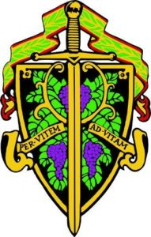  KNIGHTS OF THE VINE - DC  invites you to join us for an evening of fun, fellowship and wine at  - the Thomas Jefferson Dinner  The Field and Main Restaurant  8369 W. Main Street  Marshall, VA 20115  The chef is excited to be planning this special meal for the Knights of the Vine. Master Heralder Walt Rachele and “Forever First Guest” Pat Valas have opened their Cellar for an all Linden Dinner. As many may know, Jim Law of Linden Vineyards has been making world class Virginia wines for over 30 years. Pat has been collecting Linden wine for nearly as long, and has allowed access to a lateral of one vintage. This generosity convinced Jim to join us and speak about his wines.  Featuring Red, Rose' and White Wines | Sat, Nov 17, 2018  $175 pp  Social: 6:30 PM  Dinner: 7:00 PM  Rooms are available at the Hampton Inn, Warrenton  You don’t want to miss this one of a kind Virginia Wine event!  Send payment to: Walter Rachele  Made out to: Treasurer KOV, PO Box 264  Lovettsville, VA 20180  By: 18 Oct 2018

